- Apply Blend and Join for Customer, Customer Order, Product details sheet to display Customer ID, Order ID, Product ID, Product Name without any data loss and *.
Dataset:
- Customer : https://itv-contentbucket.s3.ap-south-1.amazonaws.com/Exams/Tableau/Customer.xlsx
- Customer Order : https://itv-contentbucket.s3.ap-south-1.amazonaws.com/Exams/Tableau/Customer+Order.xlsx
- Product : https://itv-contentbucket.s3.ap-south-1.amazonaws.com/Exams/Tableau/Product.xlsx

Ans: 1. Join
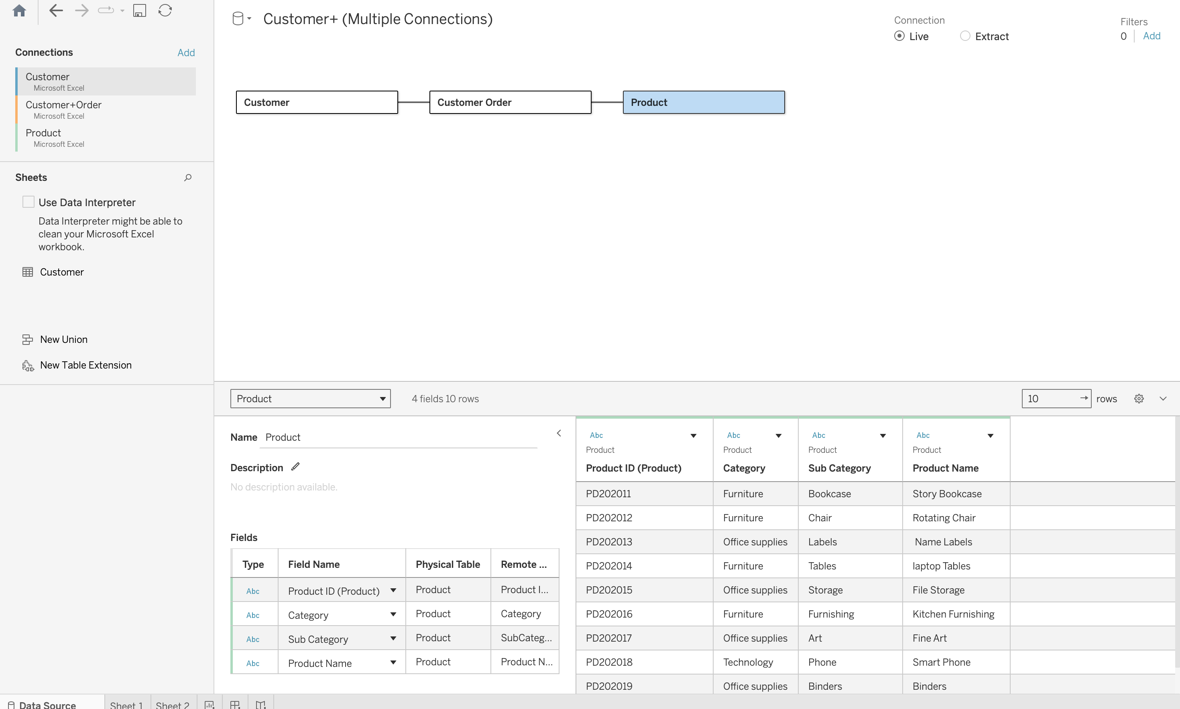
2. Output Columns

